**PROGRAM-1:**

**PROGRAM-3:**

**HTML:**

<!DOCTYPE html>

<html>

<head>

<meta charset=*"ISO-8859-1"*>

<title>Insert title here</title>

</head>

<body>

<form action=*"User"* method=*"post"*>

<h1 align=*"center"*>USER DETAILS</h1>

<table align=*"center"*>

<tr>

<td>USER NAME</td>

<td><input type=*"text"* name=*"uname"*></td>

</tr>

<tr>

<td>AADHAR ID</td>

<td><input type=*"text"* name=*"aid"*></td>

</tr>

<tr>

<td>CITY</td>

<td><input type=*"text"* name=*"city"*></td>

</tr>

<tr>

<td>STATE</td>

<td><input type=*"text"* name=*"state"*></td>

</tr>

<tr>

<td>PINCODE</td>

<td><input type=*"text"* name=*"pincode"*></td>

</tr>

<tr>

<td>NUMBER OF DEPENDENTS</td>

<td><input type=*"text"* name=*"noofdep"*></td>

</tr>

<tr>

<td>OCCUPATION</td>

<td><select name=*"occupation"*>

<option>select</option>

<option>Govt.employee</option>

<option>pvt.employee</option>

<option>labour</option>

<option>Student</option>

</select>

<tr>

<td>MONTHLY SALARY(INR)</td>

<td><input type=*"text"* name=*"salary"*></td>

</tr>

<tr>

<td></td>

<td><input type=*"submit"* value=*"submit"*> <input

type=*"reset"* value=*"reset"*></td>

</tr>

</table>

</body>

</html>

**SERVELET:**

**import** java.io.IOException;

**import** java.io.PrintWriter;

**import** java.sql.Connection;

**import** java.sql.DriverManager;

**import** java.sql.PreparedStatement;

**import** java.sql.SQLException;

**import** javax.servlet.ServletException;

**import** javax.servlet.annotation.WebServlet;

**import** javax.servlet.http.HttpServlet;

**import** javax.servlet.http.HttpServletRequest;

**import** javax.servlet.http.HttpServletResponse;

@WebServlet("/User")

**public** **class** User **extends** HttpServlet {

**private** **static** **final** **long** ***serialVersionUID*** = 1L;

**protected** **void** doPost(HttpServletRequest request, HttpServletResponse response) **throws** ServletException, IOException {

String userName=request.getParameter("uname");

String s1=request.getParameter("aid");

**long** aadharId=Long.*parseLong*(s1);

String city=request.getParameter("city");

String state=request.getParameter("state");

String s2=request.getParameter("pincode");

**int** pincode=Integer.*parseInt*(s2);

String s3=request.getParameter("noofdep");

**int** noOfDependents=Integer.*parseInt*(s3);

String occupation=request.getParameter("occupation");

String s4=request.getParameter("salary");

**double** salary=Double.*parseDouble*(s4);

**try** {

Class.*forName*("oracle.jdbc.driver.OracleDriver");

Connection cname=DriverManager.*getConnection*("jdbc:oracle:thin:@localhost:1521:xe", "system", "system");

PreparedStatement ps=cname.prepareStatement("insert into userdetails values(?,?,?,?,?,?,?,?)");

ps.setString(1,userName );

ps.setLong(2,aadharId );

ps.setString(3, city);

ps.setString(4, state);

ps.setInt(5, pincode);

ps.setInt(6,noOfDependents );

ps.setString(7, occupation);

ps.setDouble(8, salary);

**int** result=ps.executeUpdate();

**if**(result>0)

{

cname.commit();

PrintWriter out=response.getWriter();

out.println("registration done "+userName);

}

}

**catch**(ClassNotFoundException c)

{

System.***out***.println(c);

}

**catch**(SQLException s)

{

System.***out***.println(s);

}

}

}

**Output for registration:**

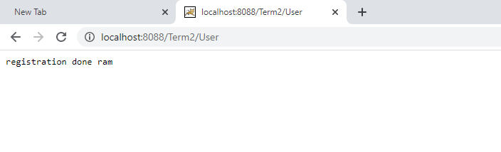

**Table:**

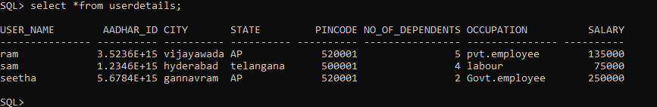

**UserSelect.html(name as UserSelect.jsp):**

<!DOCTYPE html>

<html>

<head>

<meta charset=*"ISO-8859-1"*>

<title align=*"center"*>student select</title>

</head>

<body>

<form action=*"UserSelect"* method=*"post"*>

<h1 align=*"center"*>USER SELECT</h1>

<table align=*"center"*>

<tr>

<td>Aadhar Id</td>

<td><input type=*"text"* name=*"aid"*></td>

</tr>

<tr>

<td></td>

<td><input type=*"submit"* value=*"select"*></td>

</tr>

<tr>

<td align=*"center"*><font color=*"red"*>${errormessage}</font></td>

</tr>

</table>

</form>

</body>

</html>

**SERVELET:**

**import** java.io.IOException;

**import** java.io.PrintWriter;

**import** java.sql.Connection;

**import** java.sql.DriverManager;

**import** java.sql.PreparedStatement;

**import** java.sql.ResultSet;

**import** java.sql.SQLException;

**import** javax.servlet.RequestDispatcher;

**import** javax.servlet.ServletException;

**import** javax.servlet.http.HttpServlet;

**import** javax.servlet.http.HttpServletRequest;

**import** javax.servlet.http.HttpServletResponse;

**public** **class** UserSelect **extends** HttpServlet {

**private** **static** **final** **long** ***serialVersionUID*** = 1L;

**protected** **void** doPost(HttpServletRequest request, HttpServletResponse response) **throws** ServletException, IOException {

String s1=request.getParameter("aid");

**long** aadharId=Long.*parseLong*(s1);

**try** {

Class.*forName*("oracle.jdbc.driver.OracleDriver");

Connection cname=DriverManager.*getConnection*("jdbc:oracle:thin:@localhost:1521:xe", "system", "system");

PreparedStatement ps=cname.prepareStatement("select * from userdetails where aadhar_id=?");

ps.setLong(1, aadharId);

ResultSet re=ps.executeQuery();

**if**(re.next())

{

cname.commit();

PrintWriter out=response.getWriter();

out.println(re.getString(1)+" "+re.getString(3)+" "+re.getString(4)+" "+re.getString(7)+""+re.getDouble(8));

}

**else**

{

request.setAttribute("errormessage","please enter correct id");

RequestDispatcher rd=request.getRequestDispatcher("UserSelect.jsp");

rd.forward(request, response);

}

}

**catch** (ClassNotFoundException e)

{

System.***out***.println(e);

}

**catch**(SQLException s)

{

System.***out***.println(s);

}

}

}

**OUTPUT:**

